Design and implement python code for backing up a folder into a zip file

Output:

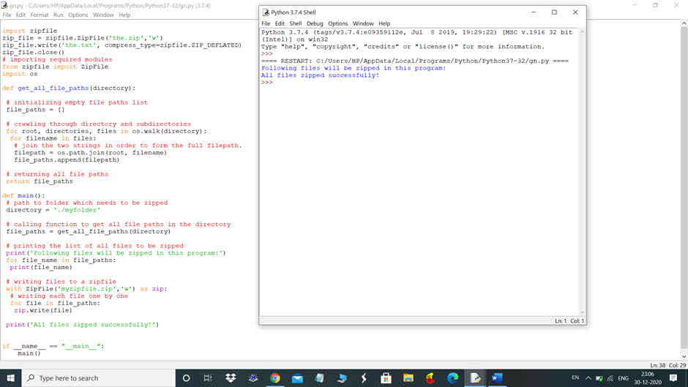

the .zip(the.txt created to zip)

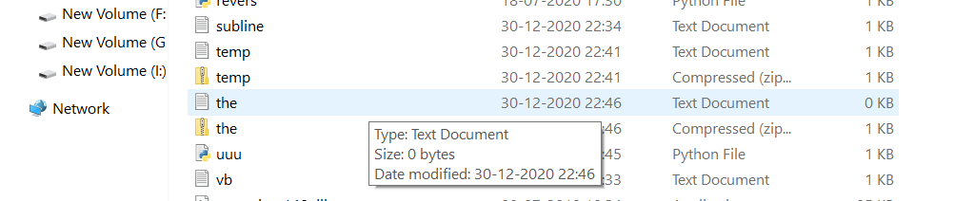

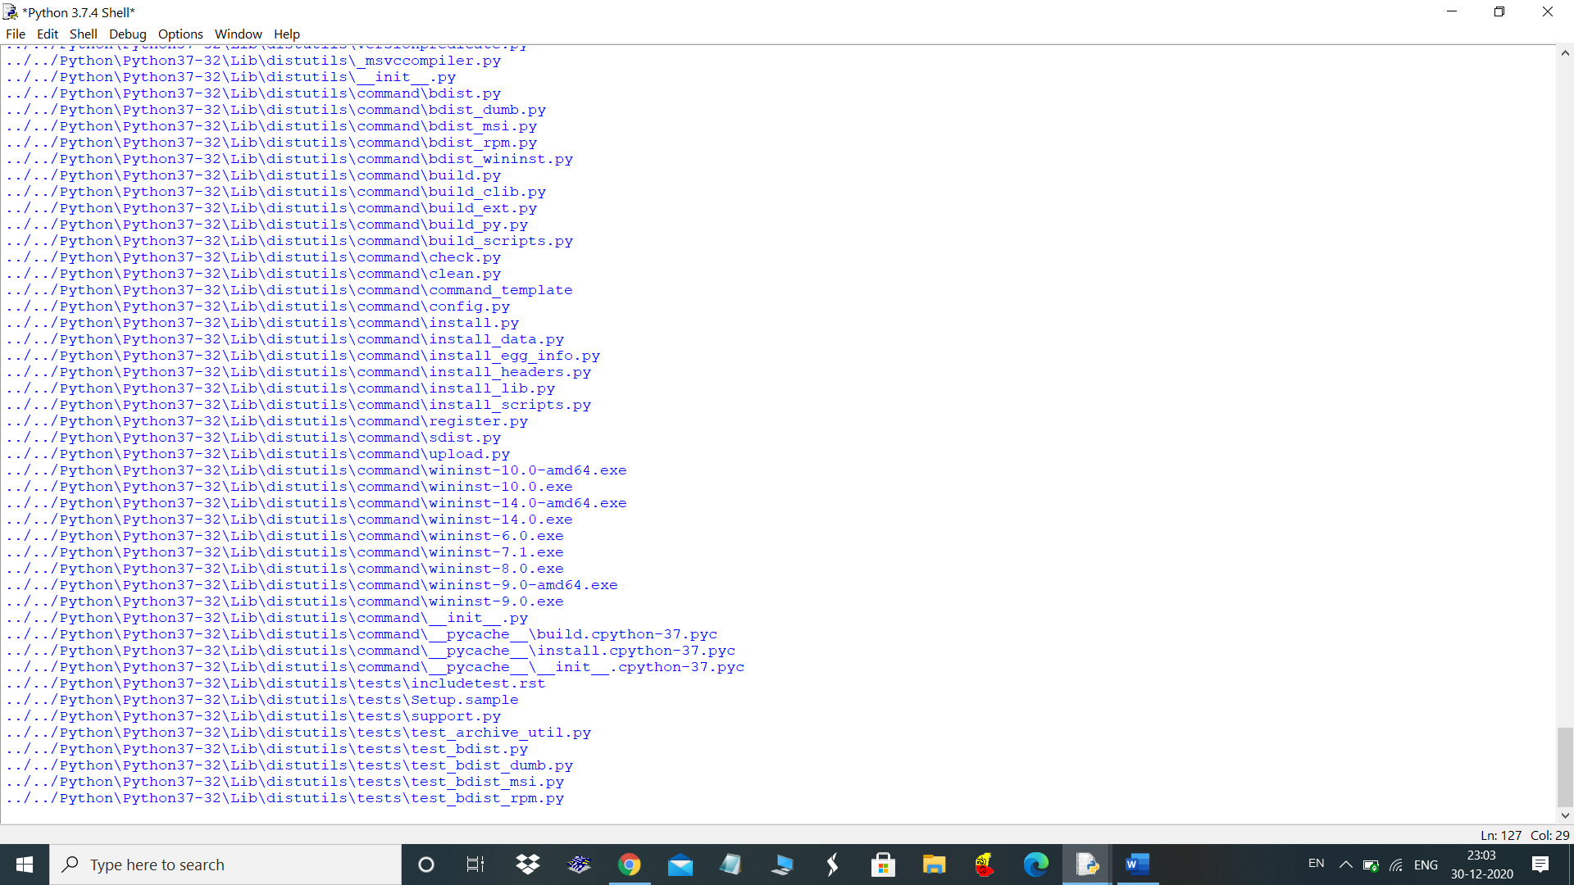

Path in python folders :